Julius Brighton

Emmy Award Winning

And BAFTA Nominated

Director of Photography

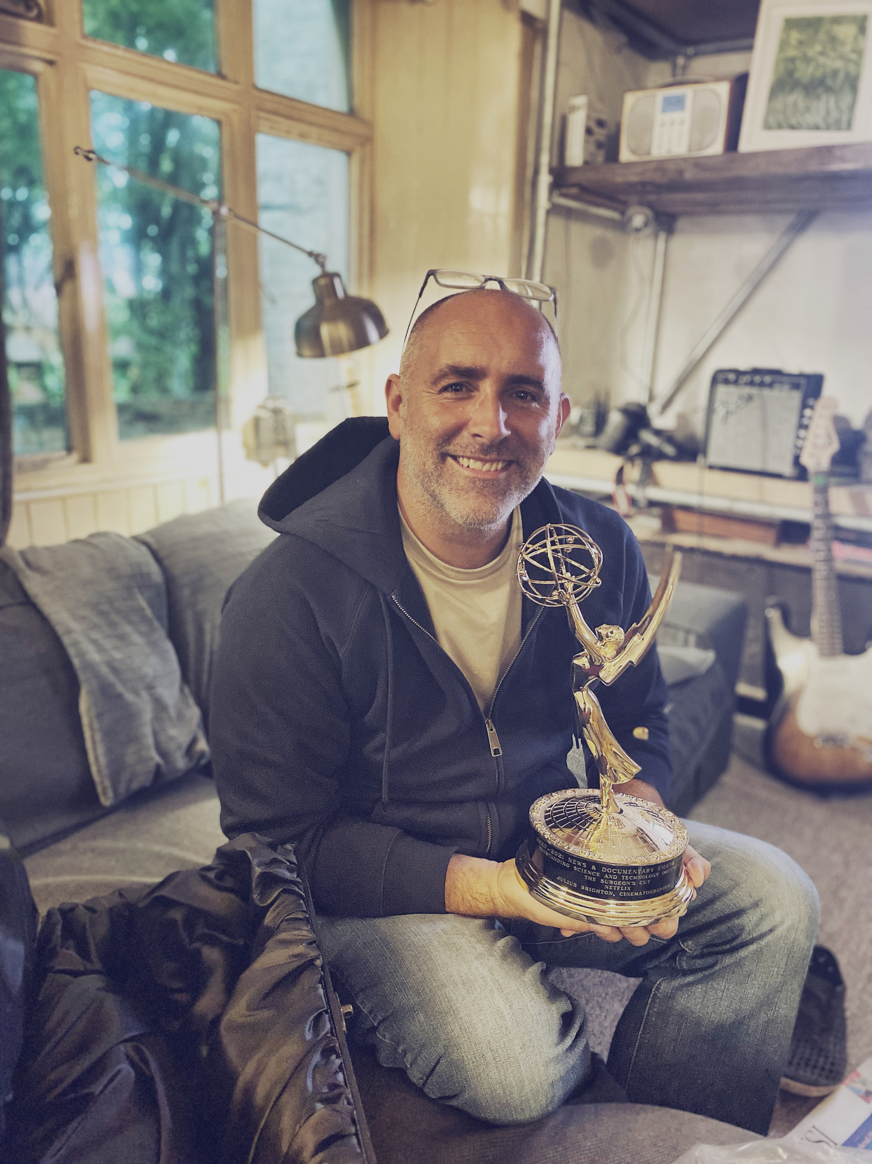
www.JuliusBrighton.com
julius@juliusbrighton.com
+44 (0) 7968 800 171
Full clean British License
Two British Passports held inc I-visa

In Brief: I’m a Documentary D.O.P with 30yrs of experience. Often working in remote locations in challenging conditions, contributing to noteworthy and award winning programs for the major TV Broadcasters world wide. I film wide ranging themes in science, natural history, travel, history, expeditions and adventure.

Skills: I have experience using the latest Digital Cinema Cameras, Gimbals, Drones, Digital time-lapse photography. Use of Jibs, tracks, mini cams, long lens configurations, high speed cameras and light weight motion-control.

Most importantly I have a great ‘eye’ combined with the skill to build compelling sequences and narratives effectively and efficiently from real life situations. Working in small teams closely with Directors and Presenters to achieve their goals.

Equipment: RED Gemini documentary package. Sigma Cine Lens set. Fujinon Cabrio 19-90mm. All supporting equipment.

Other Interests: Surfing, Sailing. Family life at home in Cornwall.

Currently In Production

Offspring An expedition Natural History series
Walking with Dinosaurs BBC London. Dinosaur dig shoot in Utah and Specific GFX Plates shoots.
Planets 2 BBC - Brian Cox. Filming presenter sequences on location in Alaska and Moab Desert.
Home BBC Natural History Unit. On Location in Chad filming Crocodiles.

Recent Experience

Secrets of the Elephants Oxford Scientific for Disney/National Geographic. Voiced by Natalie Portman.
Forest Elephant Sequence in Congo

Earth BBC. Various Presenter shoots with Chris Packam in Iceland and Canaries.

Our Universe Netflix / BBC Voiced by Morgan Freeman. Chimpanzee program filmed in Gabon and Camaroon. Cheetah program filmed in Tanzania and Namibia.

Earthshot A Silver Back Films production for BBC. Prince William join forces with Sir David Attenburough tto lauch what the hope will be The Nobel Prize for environmentalism.

Universe BBC. Professor Brian Cox journeys across the vastness of time and space revealing epic moments of sheer drama that changed the universe forever.

Surgeons Table Netflix / BBC. Four surgeons reflect on their lives and professions in this inspiring docuseries. This is the work that got awarded the Emmy.

Alien Worlds Netflix. A Wall to Wall production. Directed by Nigel Paterson and Dan Smith
Alien Worlds is a British sci-fi nature docufiction narrated by Sophie Okonedo

One Strange Rock 2 Will Smith - National Geographic. A Nutopia Production. Filming on RED. The 2nd series and follow up to the hugely successful ‘One strange Rock’

Perfect Planet A Silver Back Films production for BBC and Global release. Directed by Dan Rasmussen.

Recent Experience

The Planets BBC. 5x1hr Filmed on Sony F55 and RED. Professor Brian Cox explores the dramatic lives of the eight majestic planets that make up our solar system.

Return to the Nile National Geographic. Woodcut media. 3x 1 hrs. ‘Worlds greatest living explorer’ Sir Ranaulph Fiennes and his cousin Emmy nominated actor Joseph Fiennes embark on an adventure, retracing his 1969 expedition along the Nile.

Mission Galapagos BBC1, 3x 1hr Filmed on Sony F55. Directed by Ben Lawrie. A boat based expedition in the Galapagos islands. Presenter Liz Bonnin follows scientist above and below the water in their efforts to undertand and conserve this immensly important wilderness and its unique inhabitants.

One Strange Rock National Geographic. Netflix. 10x 1hrs. Filmed on RED. The extraordinary story of Earth and why it is special and uniquely brimming with life among a largely unknown and harsh cosmic arena; Hosted by Will Smith, astronauts tell the story from their unique perspective.

Forces of Nature BBC1, 4x 1hr Filmed on Sony F55 and RED. In his first series for BBC One, Professor Brian Cox will take viewers on a grand tour of planet Earth to explain what lies behind its startling beauty. After journeying around the Solar System and out to the edges of the universe, Brian brings viewers back to Earth to unveil the forces that make our planet what it is.

City In the Sky BBC1, 3x 1hr Filmed on Sony F55. At any one time there are a million people airborne somewhere in the world. Science broadcasters Dallas Campbell and mathematician Dr. Hannah Fry set off around the world to uncover the invisible global networks and complex logistics that make it all possible.

First Civilisations PBS, Wall to Wall for PBS, 3x 1hr Filming on Sony F55, A look at Man’s early civilisations. From the Jungles of Guatemala to the ancient citys of Pakistan.

End of the Dinosaurs BBC1, Landmark 1x1hr. Directed by Ben Lawrie. A crack team of scientists on a Drill rig expedition in the Gulf of Mexico.

First Peoples Wall to Wall for PBS, 3x 1hr Filmed on Sony F55, Directed by Nigel Walk. A look at the journey modern man had to take leaving Africa through Asia and onto Australasia.

The Treasure Hunters BBC1, 2x 1hr. Filmed on RED Epic. From pirate hoards and shipwrecked booty to dazzling gems and precious metals, Ellie Harrison and Dallas Campbell journey around the globe on the ultimate treasure hunt.

Operation wild BBC1, 3x 1hr Filming on RED Epic. Various Directors. Clare Balding and Steve Leonard join teams of pioneering vets around the world who are using the most cutting-edge techniques, often adapted from human medicine, to save the lives of animals.

Human Universe BBC1. Navaho Indian sequence - Episode 3. Director Nat Sharman. Illustrating the possiblity that we are not alone.

Stargazing live BBC2. VT Inserts filmed on location in USA. Director Penny Palmer. Dara O Briain explains gravity and acceleration by flying on the vomit commit and taking a spin in a centrifuge.

Supersized Earth BAFTA nominated for Factual Photography 2013. BBC1, 3 x 1hr Filmed on RED Epic and F3’s. Director of Photography. Directed by Nat Sharman. Two year’s in the making ‘Supersized Earth’ traces the spectacular story of how humans have transformed our world in just a single generation. In this awe-inspiring three-part series for BBC One, Dallas Campbell travels the globe, visiting the world’s largest and most ambitious engineering projects, exploring the power of human ingenuity and the making of the modern world.

BT Para Olympic 5 x Short films for CH4. Filmed on Red Epic. Director of Photography. Directed by Stewart Sugg. Para Olympic champions including Oscar Pistorius, Johnnie Peacock and Lee Pearson talk about their victories.

Inside the Human Body BBC1 Director of Photography. Red One/Canon 5d. Directed by Nat Sharman. RTS Nominated. A high quality, almost a ‘fairy tail’ documentary series examining the Human body in all its splendor. Filmed across the globe over a 10 month period. Stories ranged from a newborn babies first breath, cleft pallet surgery in India to the oldest conjoined twins alive.

Previous Experience

Disney Promos Director of Photography. Directed by Marcus Thomas. Red Epic / Green screen shoot in the NEP Studio Cardiff. Working with kids in virtual environments to create Disney Christmas promos

Three Men In A Boat BBC - Liberty Bell. Directed by Konrad Begg. Griff Rhys Jones, Dara
O’Briain and Rory McGrath once again the trio reunite and on this occasion travel and squabble through the Hebrides following Boswells ‘Tour to the Hebrides’

Bang Goes The Theory BBC. Studio links for a science magazine series presented by Dallas Campbell, Liz Bonnin and Jem Stansfeild.

Grand Designs Talkback Thames. Ch4. Designer and writer Kevin McCloud follows the structural, financial and emotional journey of each build over many months.

Can we save BBC. Emmy award winning climate change documentary presented by David
Planet Earth Attenborough. Director by Nic Brown.

Jimmy’s Global Farm BBC Scotland. Directed by Nat Sharman. Jimmy Doherty looks at agriculture around the globe.

The Eden Project Director of Photography for the ‘Eden Sessions’ Live Music events. Artists include Oasis, Kasabian, Paul Weller, Razorlight & the Kooks.

Freesports on Four Channel 4 - Boomerang TV. RTS and BAFTA award winning series. 52 part, presenter led programming covering action sports and lifestyle.

Inside the BBC4. Directed by Nat Sharman. Professor Robert Bartlett takes a look at the
Medieval Mind thought process of people in Medieval Europe. The program received the best viewing figure for BBC4 of all time.

IF Waste BBC Two - Current Affairs. Director Nick Brown. Documentary/drama. Digi beta camera op.

Terror Alert Sky One - Scream Films. BAFTA Nominated. Ex-SAS serviceman Chris Ryan guides the viewer through methods on how to survive the worst-case scenarios including being taken hostage on a 747 jet and a nuclear bomb explosion. Involving expert interviews and reconstructions.

Urban Survival Sky One - Scream Films . Ex-SAS serviceman Chris Ryan guides the viewer through methods on how to improve self-awareness and how to be more street wise. Involving expert interviews and re-constructions.

Extreme Survival Discovery. Darlow Smithson. Follow up series to ‘Touching the
void’. Digibeta B-roll and water cam operator for drama reconstruction
Vancouver Island, BC.

Billabong Odyssey Arenaplex. Cinema Release. Big Wave riding Surf documentary.

The Cape Epic The toughest mountain bike race on the planet, described as an all terrain Tour de France. Filmed in South Africa over 550 miles from the back of a BMW Adventure Enduro motorbike.

The TAWR Documentary about a Windsurfing expedition across the North Atlantic. The 2 week race was based from the 130 meter Russian ice breaker, The ‘Captain Kalapnkov.’

Mono MTV - Basik Product. 16mm Short form freesports films.

O’Neill Europe Various projects and Directors. From fashion features to professional world tour Surf and Snowboard events. Inc The Cold Water Classic Tour and Exploration boat trips in French Polynesia.

Surfing World Tour Distributed world wide SMG. A series of 12 one-hour shows, competition based with athlete profiles and travel features. Shot on Digital Beta Worldwide.

Mountain Bike Britain Channel 4 – SSM .UK Tour. Series cameraman on 24 shows.

Triathlon World Cup SSM. World Tour. Series cameraman on 12 shows.

World Windsurfing SSM. World Tour Series cameraman for 100 half-hour shows.

